#Module 4

Q1. Digit Sum
#code
int main(){
int T, num, first, last;
scanf("%d", &T); // Reading number of test cases
while (T > 0) {
scanf("%d", &num); // Reading the number
last = num % 10; // Getting last digit
first = num;
while (first >= 10) {
first = first / 10; // Getting first digit
}
printf("%d\n", first + last); // Printing sum
T--;
}
return 0;
}

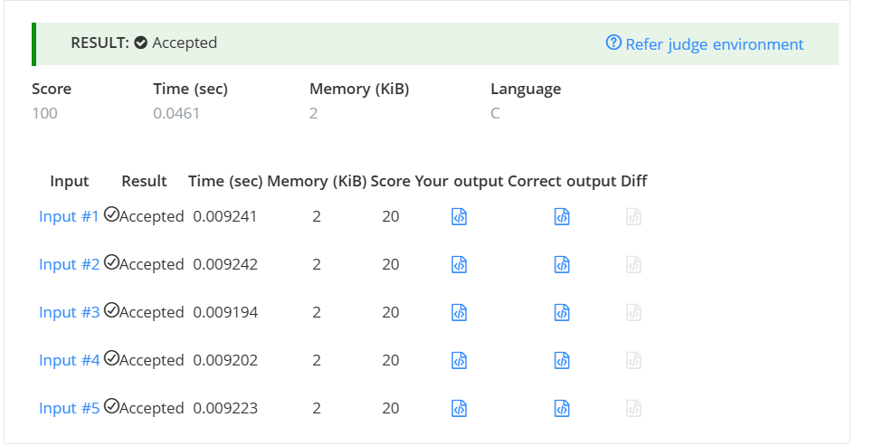

Q2. Find Digit
#Code
int temp, digit, count = 0;
temp = n;
while (temp > 0) {
digit = temp % 10;
if (digit != 0) {
if (n % digit == 0) {
count++;
}
}
temp = temp / 10;
}
return count;
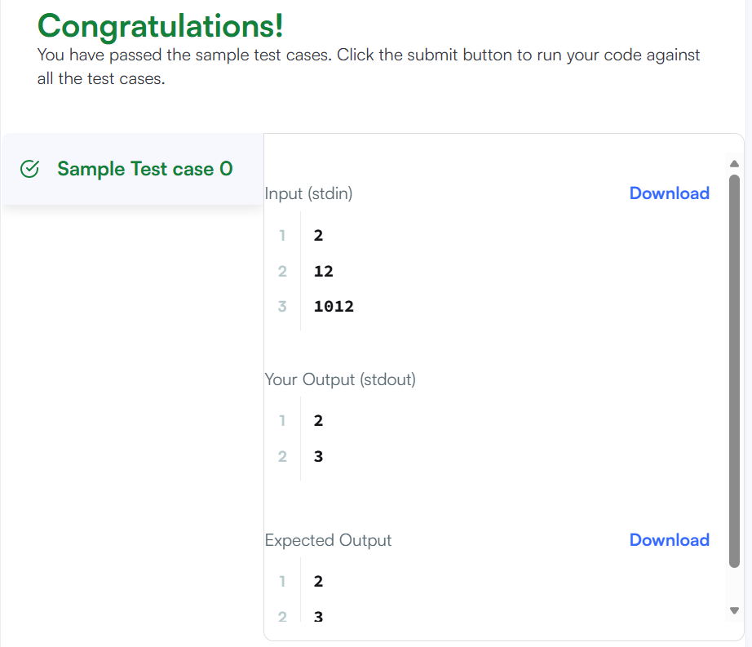

Q3. 1281 — Subtract the Product and Sum of Digits
#Code
class Solution {
public:
int subtractProductAndSum(int n) {
int sum = 0;
int product = 1;
int digit;
while (n > 0) {
digit = n % 10;
sum = sum + digit;
product = product * digit;
n = n / 10;
}
return product - sum;
}
};

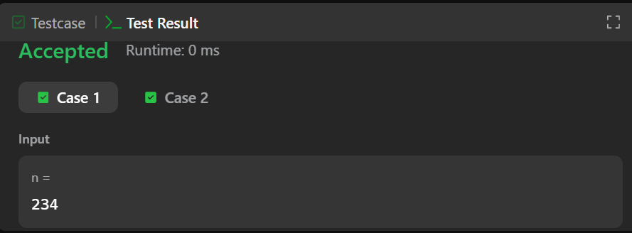

Q4.2520 — Count the Digits That Divide a Number
#code
class Solution {
public:
int countDigits(int num) {
int temp = num;
int digit;
int count = 0;
while (temp > 0) {
digit = temp % 10;
if (num % digit == 0) {
count++;
}
temp = temp / 10;
}
return count;
}
};

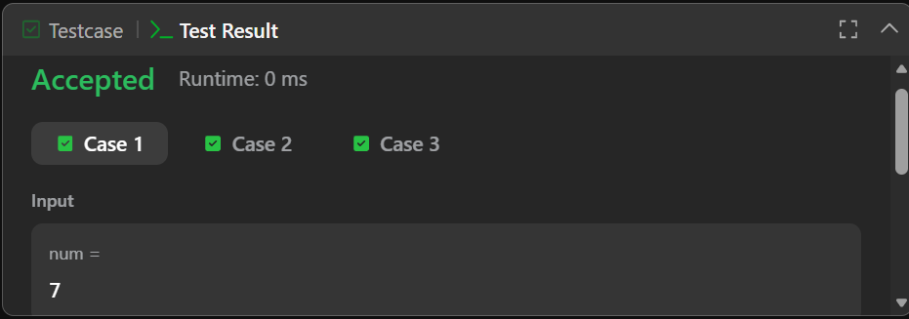

Q5. 9 — Palindrome Number
#Code
class Solution {
public:
bool isPalindrome(int x) {
int original = x;
int reverse = 0;
int digit;
if (x < 0) {
return false;
}
while (x > 0) {
digit = x % 10;
reverse = reverse * 10 + digit;
x = x / 10;
}
if (original == reverse) {
return true;
}
else {
return false;
}
}};
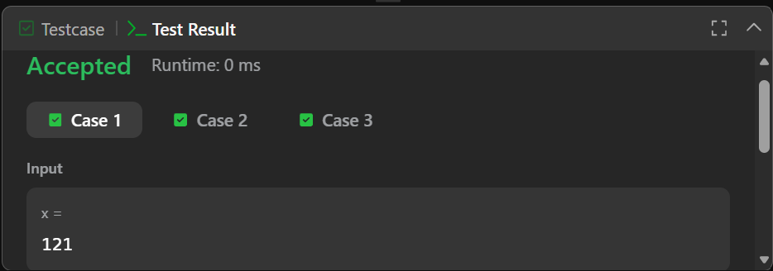

Q6. 7 — Reverse Integer
#Code
class Solution {
public:
int reverse(int x) {
int rev = 0;
int digit;
while (x != 0) {
digit = x % 10;
if (rev > INT_MAX / 10 || rev < INT_MIN / 10) {
return 0;
}
rev = rev * 10 + digit;
x = x / 10;
}
return rev;
}
};
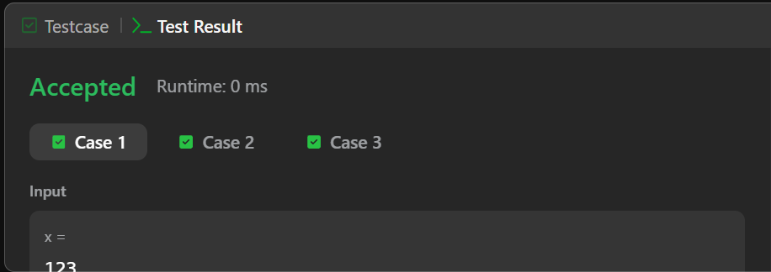

#Module 5

Q1. 231 — Power of Two
#CODE
class Solution {
public:
bool isPowerOfTwo(int n) {
if (n <= 0) {
return false;
}
while (n % 2 == 0) {
n = n / 2;
}
if (n == 1) {
return true;
}
else {
return false;
}
}
};
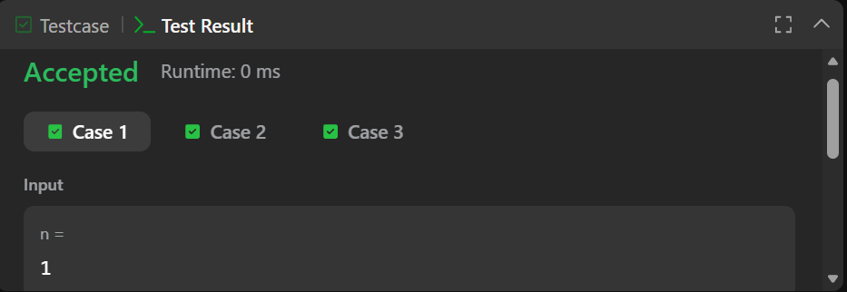

Q2. 326 — Power of Three
# CODE
class Solution {
public:
bool isPowerOfThree(int n) {
if (n <= 0) {
return false;
}
while (n % 3 == 0) {
n = n / 3;
}
if (n == 1) {
return true;
}
else {
return false;
}
}
};
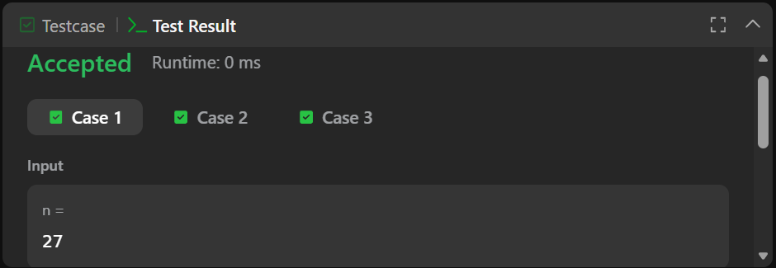

Q3. Factorial!
#CODE
#include <stdio.h>
int main() {
int num;
long long fact = 1;
scanf("%d", &num);
for (int i = 1; i <= num; i++) {
fact = fact * i;
}
printf("%lld\n", fact);
return 0;
}
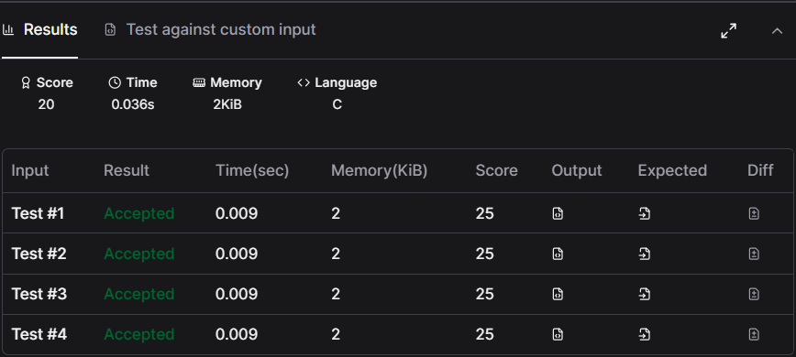

Q4. Count Divisors
#CODE
#include <stdio.h>

int main() {
int l, r, k;
int count = 0;
scanf("%d %d %d", &l, &r, &k);
for (int i = l; i <= r; i++) {
if (i % k == 0) {
count++;
}
}
printf("%d\n", count);
return 0;
}
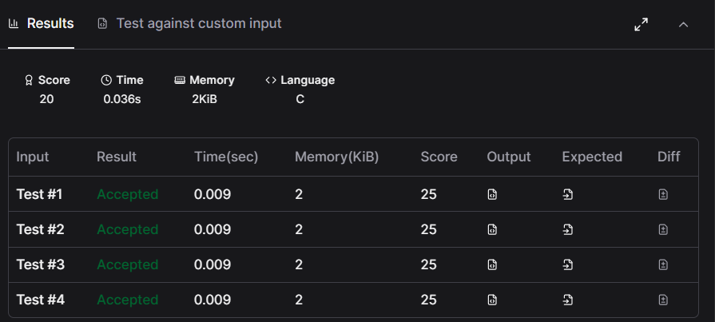

Q5. Prime Numbers
#CODE
#include <stdio.h>
int main() {
int num;
int count = 0;
scanf("%d", &num);
for (int i = 1; i <= num; i++) {
if (num % i == 0) {
count++;
}
}
if (count == 2) {
printf("1\n");
}
else {
printf("0\n");
}
return 0;
}
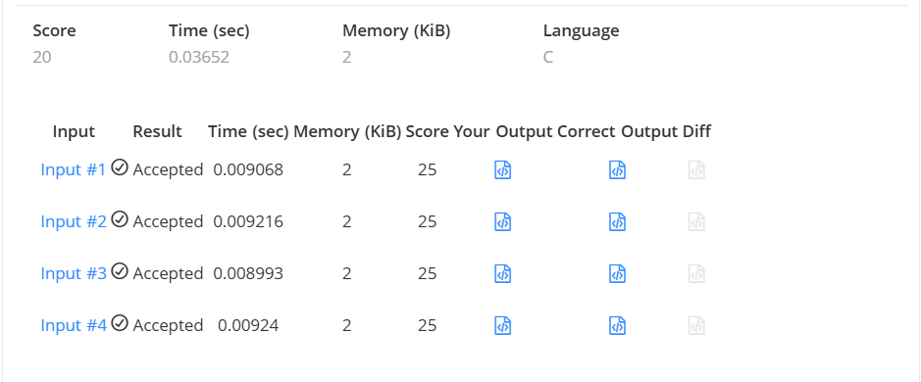

Q6. 507 — Perfect Number
#CODE
class Solution {
public:
bool checkPerfectNumber(int num) {
if (num <= 1) {
return false;
}
int sum = 1;
for (int i = 2; i <= num / 2; i++) {
if (num % i == 0) {
sum = sum + i;
}
}
if (sum == num) {
return true;
}
else {
return false;
}
}
};
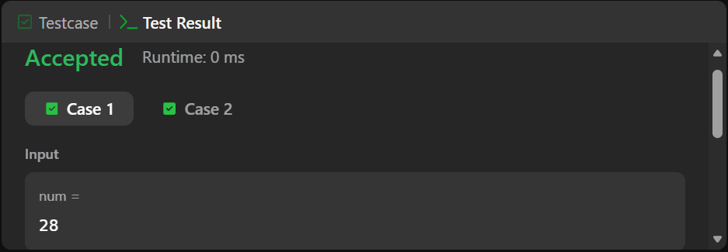

#MODULE 6

Q1. Staircase
#CODE
void staircase(int n) {
for (int i = 1; i <= n; i++) {
for (int j = 1; j <= n - i; j++) {
printf(" ");
}
for (int k = 1; k <= i; k++) {
printf("#");
}
printf("\n");}}
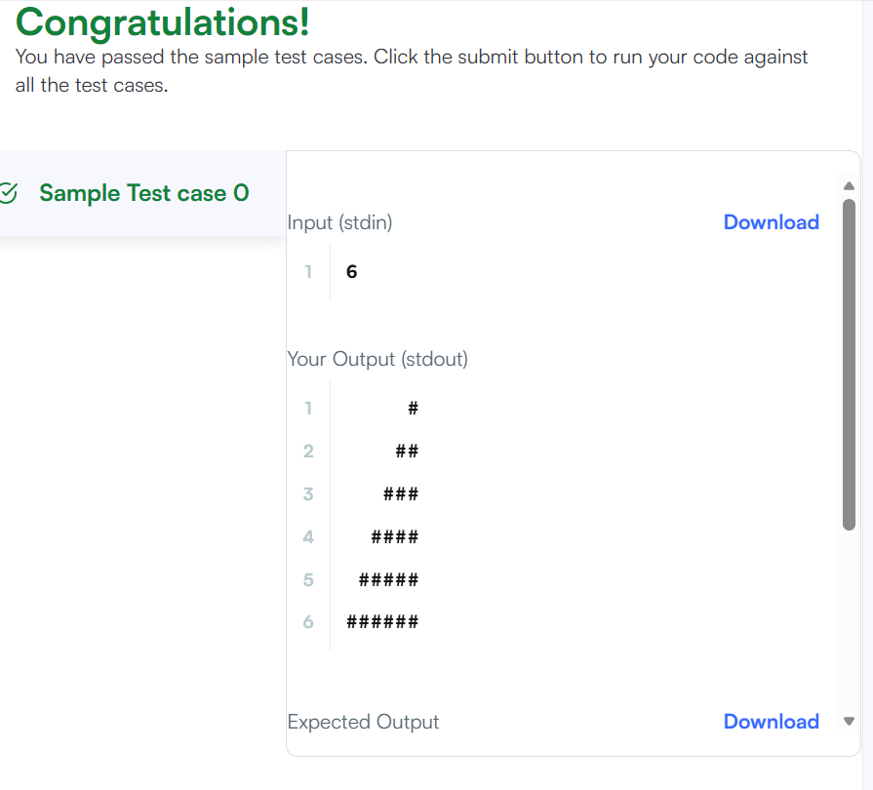

Q2.Printing Pattern Using Loops
#CODE
#include <stdio.h>
#include <string.h>
#include <math.h>
#include <stdlib.h>

int main()
{
int n;
scanf("%d", &n);

for (int i = 0; i < 2 * n - 1; i++)
{
for (int j = 0; j < 2 * n - 1; j++)
{
int a = i;
int b = j;

if (a > 2 * n - 2 - i)
a = 2 * n - 2 - i;

if (b > 2 * n - 2 - j)
b = 2 * n - 2 - j;

int min = a;

if (b < min)
min = b;

printf("%d ", n - min);
}

printf("\n");
}

return 0;
}


